Disadvantages for Wind Power:

*Wind farms must be positioned on hills to achieve the maximum amount of wind. Occasionally this may ruin the landscape for local houses,
* The average wind farm requires approximately 17 acres of land to produce one megawatt of electricity; this amount is enough to power up to 1000 homes, more than your average coal-fire station.
*Wind farm’s can be quite expensive to maintain and the electricity produced can be expensive too, but so are other energy producers.
*Wind power kills hundreds of birds and bats with its spinning blades, but coal power plants will eventually kill hundreds and thousands of animals through pollution, acid rain and climate change.

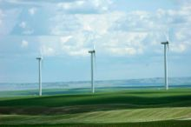

For more information go to the following resources;
http://www.greenoptions.com/wiki/wind_power_myths_vs_facts
http://en.wikipedia.org/wiki/Wind_power
http://www.energyquest.ca.gov/story/chapter08.html

Extra information on wind power

A singular wind turbine will usually produce about 50-300 kW of electricity. One kW is 1000 watts. With 1000 watts you can light ten 100-watt light globes!!
Throughout 2000 to the end of 2006 the generation of wind power more than quadrupled globally, although it still currently produces less than 1% of electricity use worldwide.
According to the British Wind Energy Association, primary legislation now exists to ensure that by 2010, 10% of our renewable energy will come from wind power and by the end of 2015, 15%.
Wind turbines can be located Onshore: in hilly or mountainous
regions:
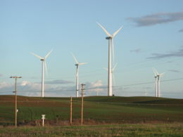
Near-shore : within 10km of a shoreline; 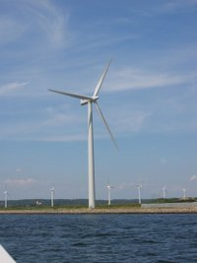
Offshore: 10km or more from any land:
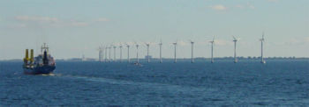

Wind Power

A cleaner and renewable alternate energy source

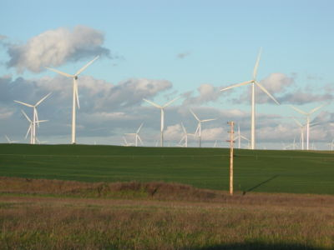

By Jessica Fleurant
8G
Greater use of wind energy will mean a cleaner and
healthier environment for you.
It means that we are relying on an energy source whose
'fuel' is free and will NEVER run out.

