Wind farms are currently located in the following places around the world:
Germany with the highest production of power: 20 622 MW. Following that are; Spain, US, India, Denmark, China, Italy, UK, Portugal, France, Netherlands, Canada, Japan, Austria, Australia, Greece, Ireland, Sweden, Norway, Brazil, Egypt, Belgium, Taiwan, South Korea, New Zealand, Poland, Morocco, Mexico, Finland, Ukraine, Costa Rico . The first wind farm was set up in November 1991.
For more information see also:
http://en.wikipedia.org/wiki/Wind_farm

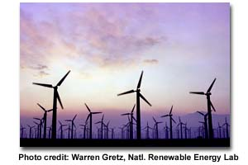

The process of making coal (our current energy source)

Wind power is the conversion of wind energy into more useful forms: usually electricity using wind turbine. Wind energy is very appealing because it is pollution free, whereas burning coal (our current energy source) releases large amounts of greenhouse gases, air pollutants and toxic metals into the atmosphere. Wind energy is renewable, clean and can be generated by the means of wind turbines found on wind farms. A wind farm is an area of land that has many turbines, but has to be located in an area where wind speeds are usually above 16 kilometers per hour. The wind has to be of this speed for the turbine to work and generate energy. Wind turbines convert the kinetic energy in the wind (the energy of moving air molecules) to electricity.mWind turbines usually have a rotor, or blades, which spin when the wind blows, and in doing this, rotate the hub. The hub is connected to a 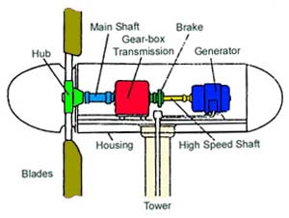gearbox, which is attached to a high-speed generator, which transforms the energy into electricity. Once all the electricity from an entire wind farm is collected together and sent through a transformer the voltage is increased (a few hundred thousand volts) so that it can be sent long distances through tall transmission lines to distant cities and factories.
For more information see also: http://www.greenoptions.com/wiki/wind_power_myths_vs_facts
A wind turbine converts the:

Kinetic Energy in the Wind (the energy of moving air molecules)

Electrical Energy Mechanical Energy

Whereas our current energy resource; coal converts

Chemical Energy Heat Energy Kinetic Energy Electrical Energy

Advantages for Wind Power:

*Coal power stations are known to make a lot of noise, but wind turbines are reasonably quiet and are known to be no noisier than the hum of a kitchen fridge when placed at a fair distance. Turbine’s blades and gearing designs have been improved to quieten the turbines so that a normal conversation can be made standing underneath one.
*The ground on which wind turbines are located can still be used for agricultural purposes such as sheep grazing.
*Turbines that are taken down leave no residue behind or any sort of damage to the ground.
* Wind power is completely renewable, is a clean resource that’s operation doesn’t produce any carbon dioxide, sulfur dioxide, mercury, particulates or any other type of air pollution into our atmosphere as does our current resource: coal.
*Fossil fuel powered stations circulate large amounts of water for cooling whereas wind stations don’t need any water to generate electricity.
*Wind power uses energy already present in the Earth’s atmosphere, and can displace fossil-fueled energy which releases carbon dioxide emissions. Thus meaning that wind energy reduces the global warming.

